1. On the search page all order types titles and descriptions show a design issue.  
   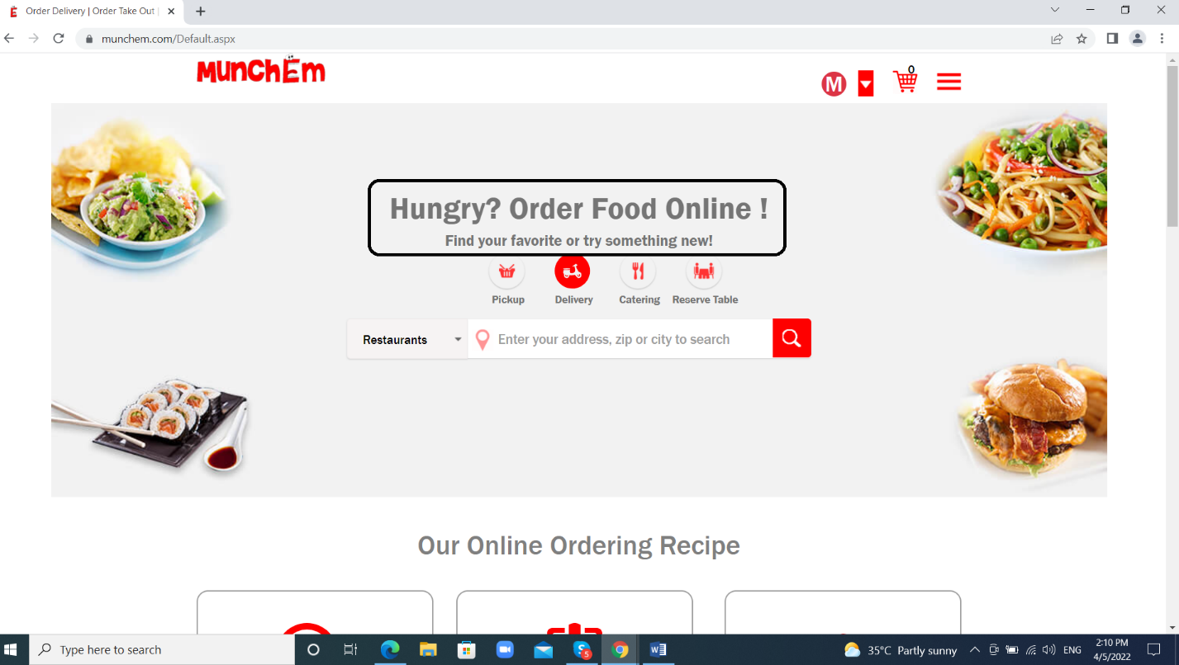  
     
   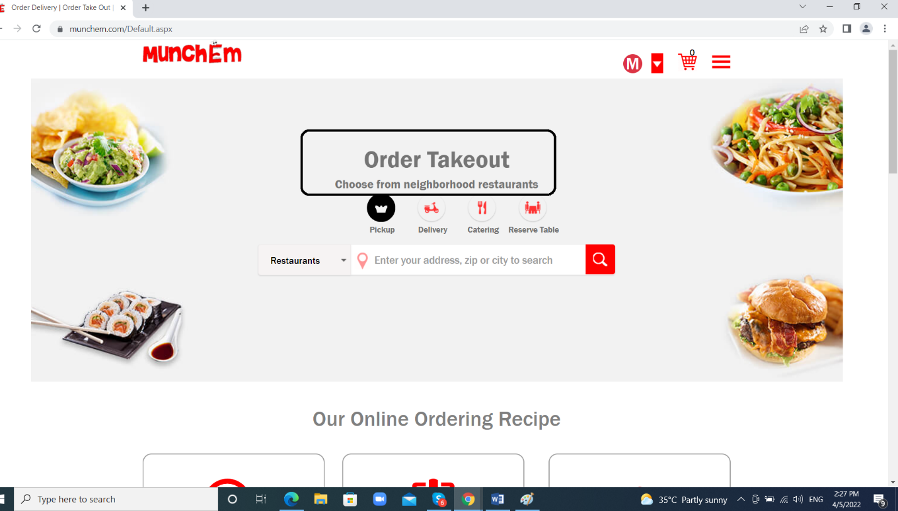
2. On my orders page I selected order id then it was opened order information but the *delivery* address showed extra space and the delivery date displaying 2 times.  
   